Single Page Web Application Final Report

I have managed to create a webpage where users can create an account and login to create and manage a collection of Magic: The Gathering cards.
The features that I have implemented are:
- Signup
- Logging in
- Logging out
- Adding more copies of cards you already own
- Removing copies of cards you already own
- Adding copies of cards the database knows about to your collection
- Viewing the contents of your collection

I also envisaged adding several other features such as:
- Searching your collection
- Sorting your collection
- Filtering your collection
- Arranging your collection into virtual decks
- Being able to show the user how many of each card they owned

Unfortunately, these features would likely take a long time to implement based on the time it has taken to create all of the features I have implemented and frankly may not have been as vital to project completion as the report, video, database dump and validation will be according to the specification.

There is some kind of bug with adding cards from the API regarding the inability to escape single quotes inside single quote-enclosed strings inside the SQL used to insert it into the database. A function has been added to explicitly escape these but seems to be intermittantly functional and non-functional making it hard to fix.

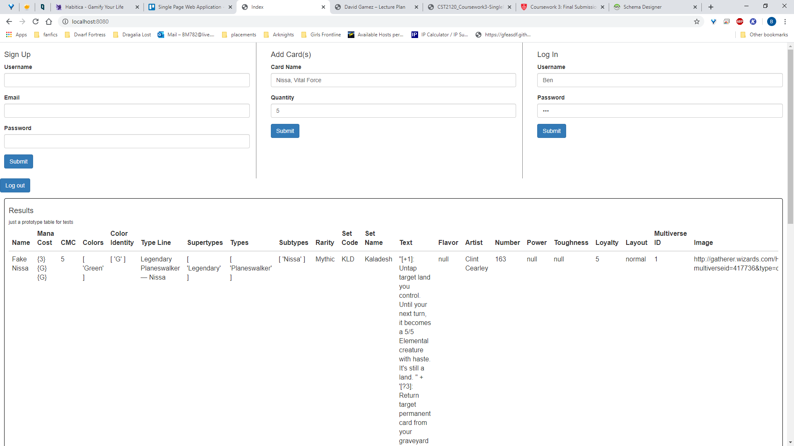

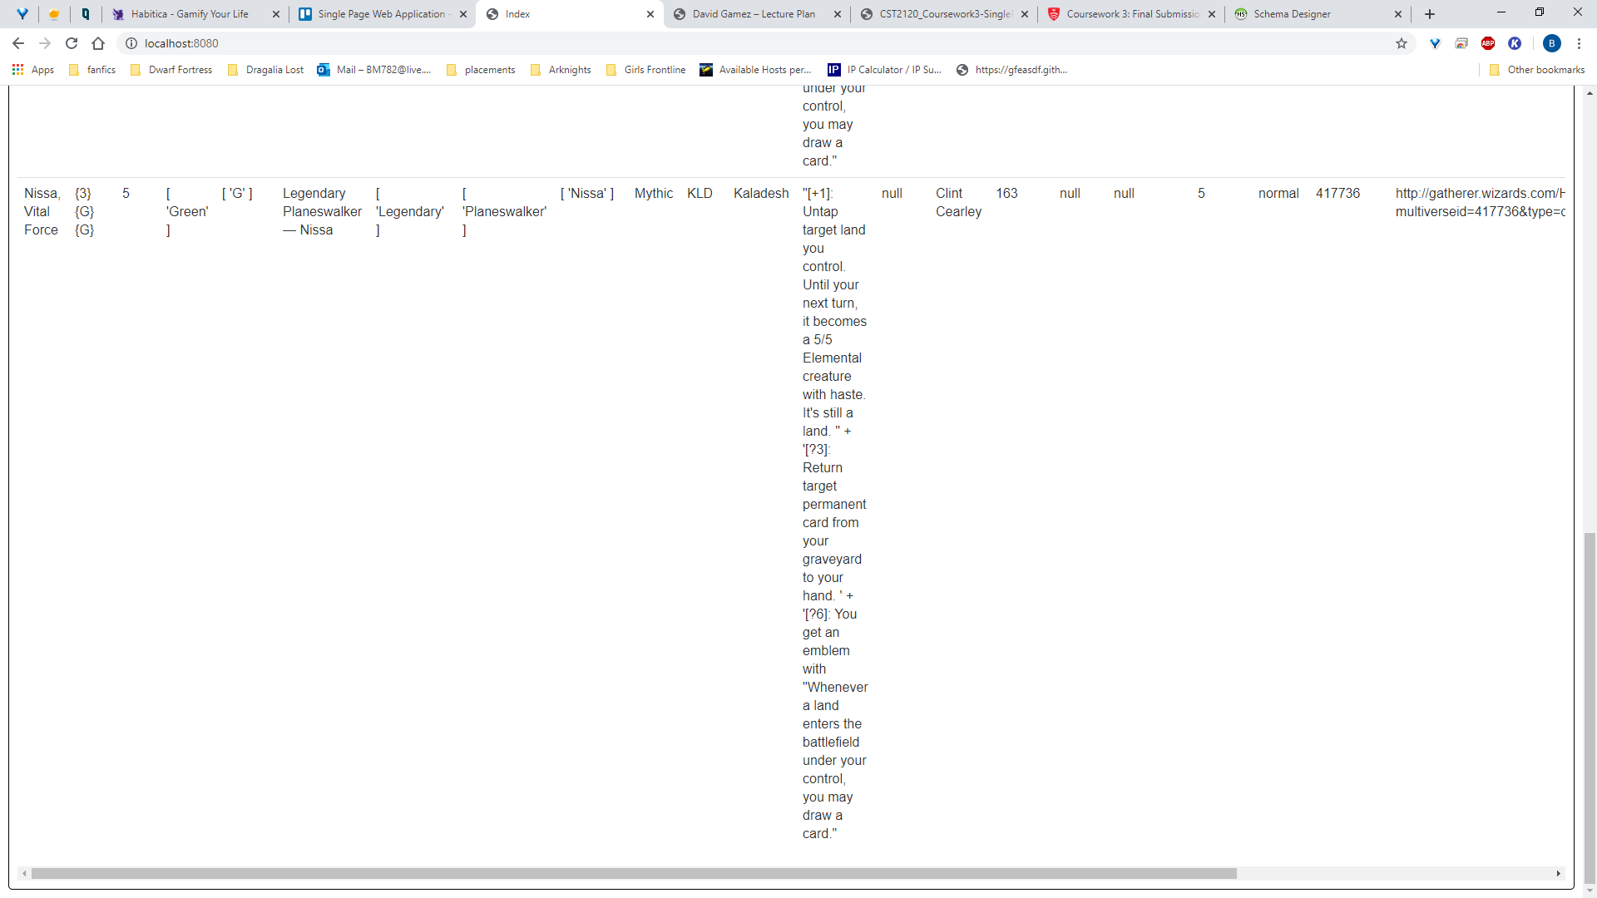
(The Bootstrap table classes seem to be overwriting any formatting I add to the HTML/CSS to alter column-width)

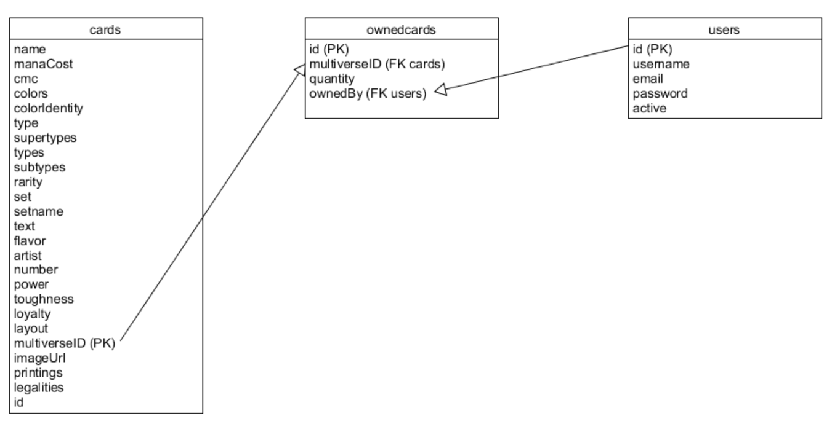
Here is a basic diagram of the database structure as reflected in HeidiSQL. I haven’t reused the one from the proposal in the event the structure is slightly different now

Here are the results of my validations after fixing the problems they highlighted
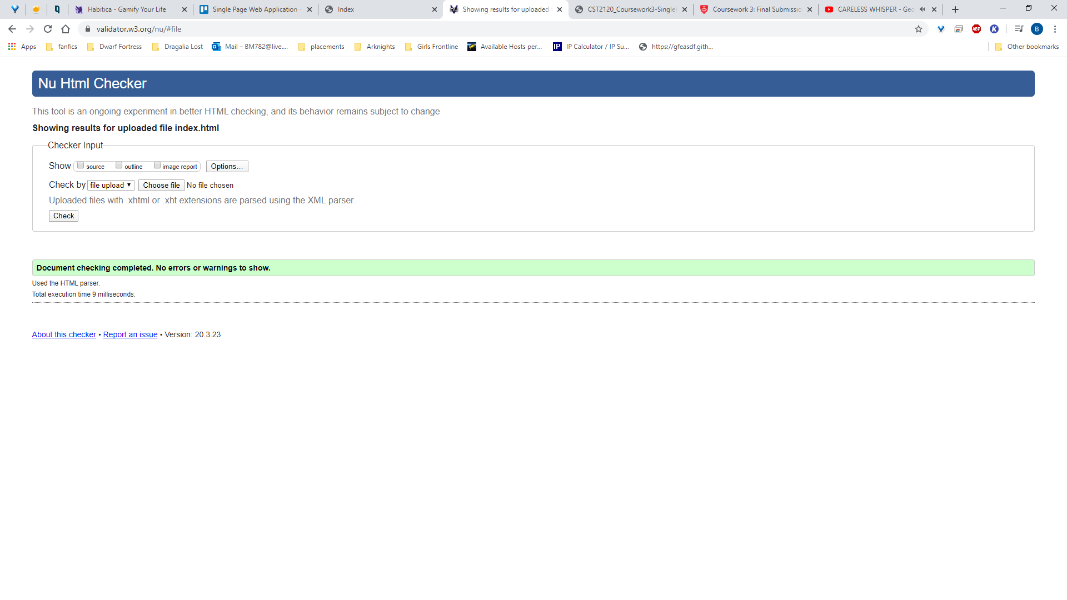
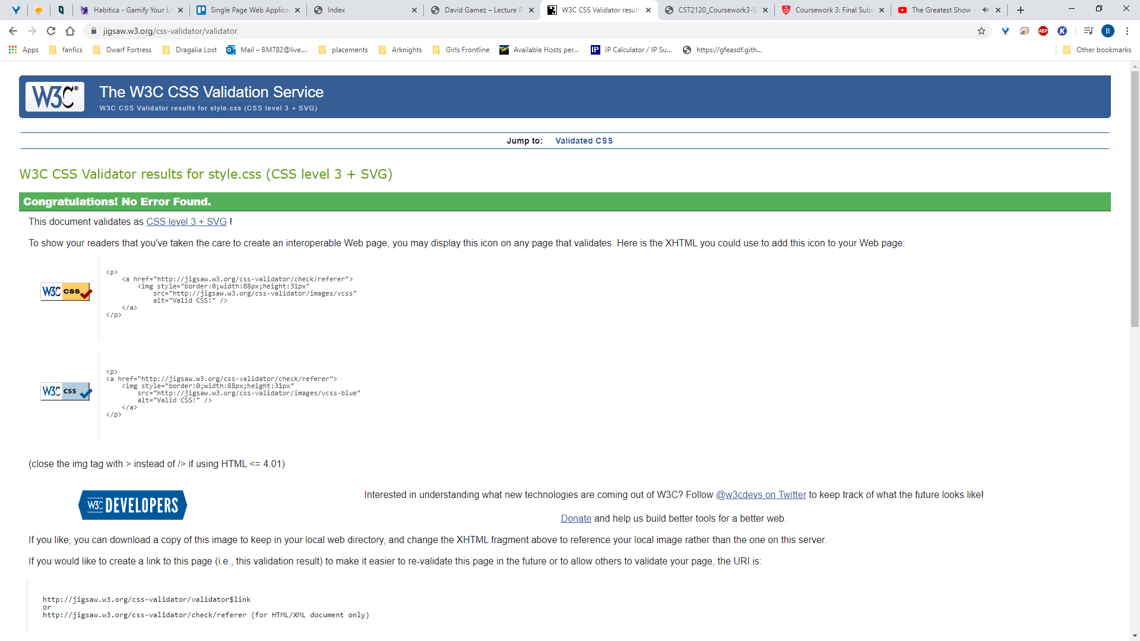
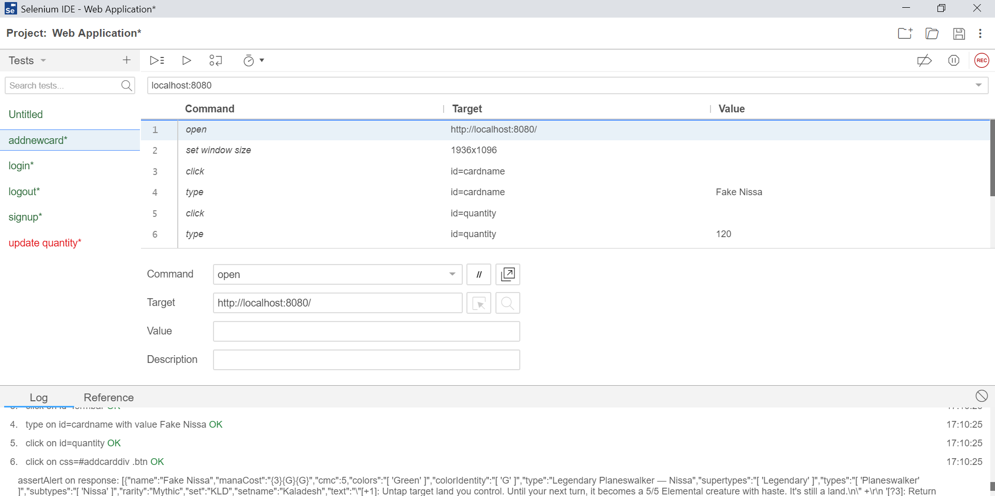
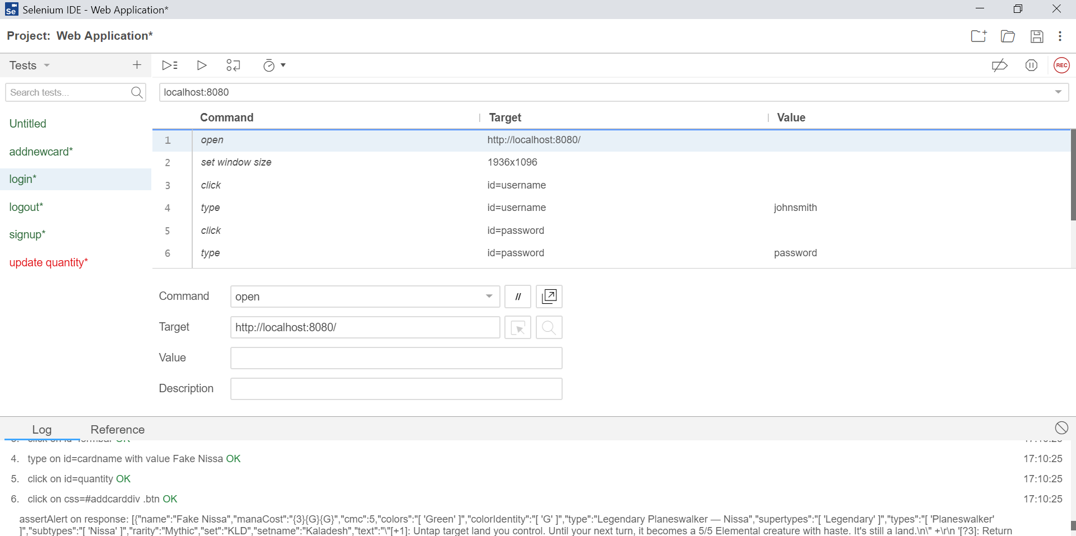

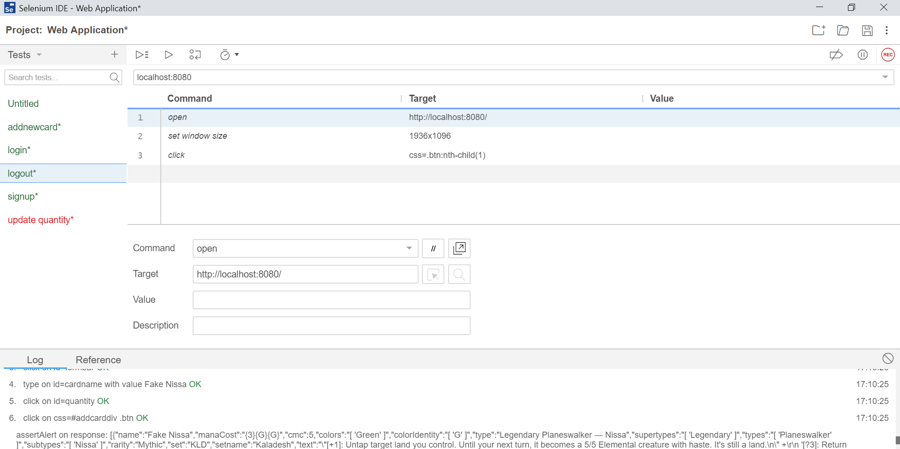

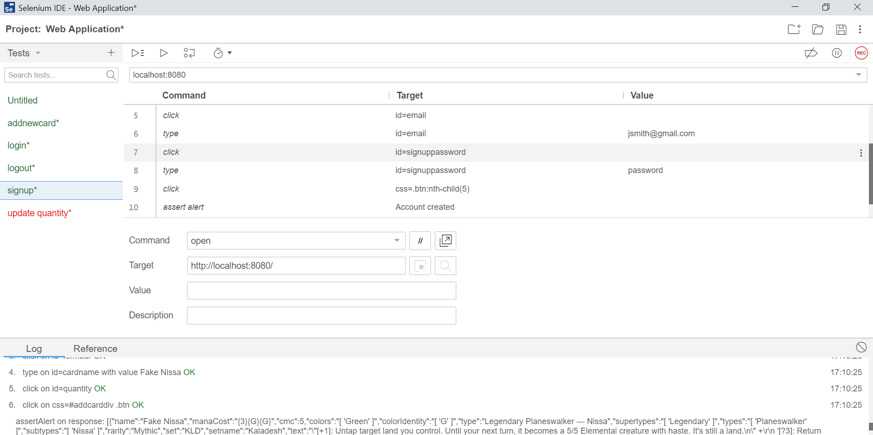

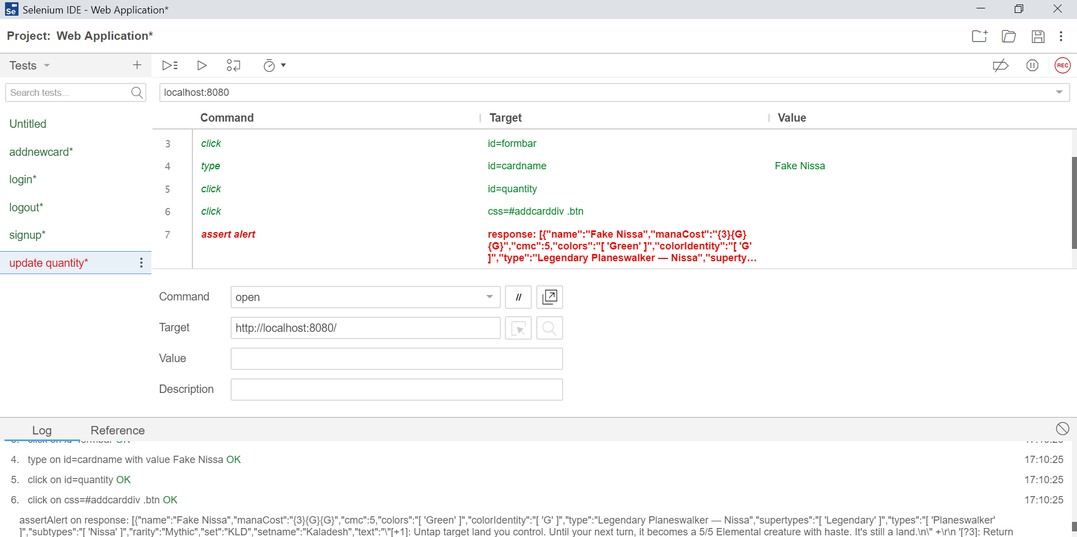
The alert at the end flashed up red but the actual code worked as far as I can tell.

